COMITAS NEWSLETTER
No. 33, May 2016

UPDATE
We celebrated the 20th anniversary of Comitas at Le Manoir on May 7th, a perfect Spring day. There were about forty of us, including members and friends, and some family members too. There was plenty of food, and lots of door prizes, and everyone had a great time.
We have some special features in this issue: greetings from friends, interviews about the beginning of Comitas, and a “Memory Lane” article.
INTERVIEW
On an afternoon in March, 2016, Charles Nicholls interviewed Elaine Whitton at AVATIL, about her recollections of Comitas, and how it got started.
Charles: How did Comitas begin?
Elaine: It began with Fay Bland and Peggy Wright who wanted to be sure their older children, already members of AVATIL, would always have a welcoming group where they could do things together, when their parents were no longer around. There was a lively meeting at the very beginning that brought together parents and carers of prospective members. I remember that among others, Peter and Erika Mazeika were present, as well as Gwen Sample and Peggy O’Byrne, then Director of AVATIL. It was an exciting time and everyone was positive and hopeful about the endeavour. Other parents, caregivers and friends soon joined the group, and the meetings were full of excitement and hope for the future. An application was made to the Canadian Government for a New Horizons grant to get the group started, and the application was successful. Around this time, a name for the group was decided upon: “Comitas” a Latin word for “friendship, civility, courtesy”. At the beginning, we had three groups: Daytimers, Moonlighters and Sunshiners.
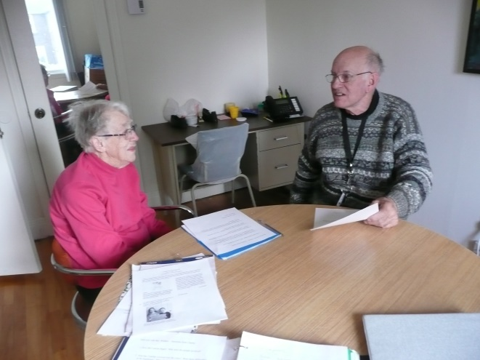
Charles: How did Comitas evolve? Were there any difficulties?
Elaine:Comitas has evolved from an idea in the minds of two people, into the thriving community it is now. At the beginning we didn’t know how much support AVATIL would be able to give us, but we were very fortunate to have had Helen Venneman assigned to us as our Co-ordinator, and our first two staff members, Kelly and Tracy, were wonderful – young, cheerful and enthusiastic. We were off to a good start, and have ever since enjoyed the continual support of AVATIL and our Executive Director, Carmela De Lisi. Things are more structured now, but our members like to know what to expect, and so they appreciate the structure.
Charles: What about Comitas traditions? Did you enjoy the trip to the Train Museum?
Elaine: Yes, of course. It was educational and historical. And there were so many others – the Planetarium, as you also mentioned, and the Wax Museum, the Chihuly Exhibit, apple picking at Quinn Farm, the Chateauguay trips, and many others. We have to remember, though, that our members are getting older, and we have to think of outings that involve less walking. But our first and strongest tradition is our Pot Lucks which have thrived from the very beginning – food is a great draw!
Charles: You were the first editor of the Newsletter. How did it start?
Elaine: It started right at the beginning. I felt we needed something that recorded what we were doing – it is like a thread going through our years together, and it is helpful to members who don’t – or cannot – participate in our activities. It lets them know what we are doing.
Charles: What does Comitas mean to you personally?
Elaine: I think my son, David, said it best: “It’s a place where everyone feels welcome and comfortable”. As for the future, maybe physical things will change, but I think the sense of belonging, getting on together and supporting each other, is more important and enduring. In this way, Comitas is really a success story.

Pot Luck at La Vieille Brasserie
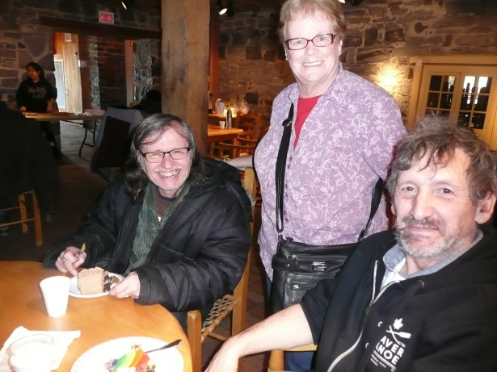
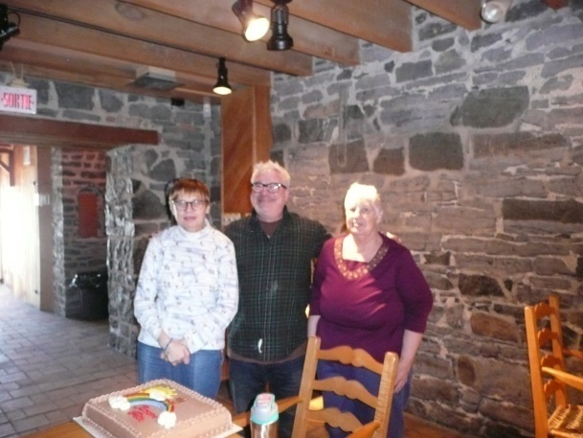Charles’ niece Susan and her husband Ken joined us on March 12th – it was Ken’s birthday! Marina and Judy also celebrated March birthdays.
And Pot Luck at AVATIL!
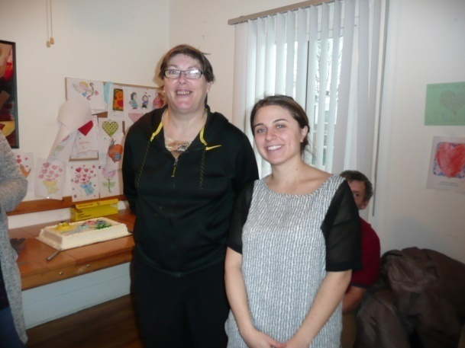The January Pot Luck unexpectedly took place at AVATIL, when the City mixed up our reservation at the Vieille Brasserie.
Christmas Fun, 2015
Therewas a huge turnout for our annual Christmas Party at Barbie’s on December 9th. We had good food and our favourite Santa distributed lots of presents.
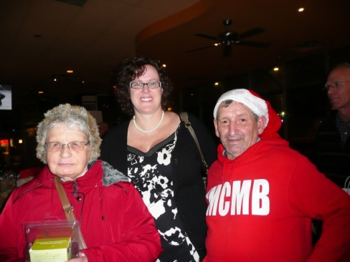

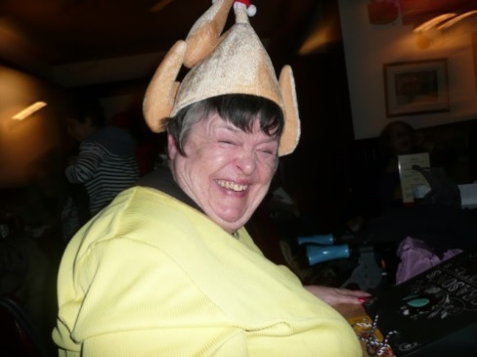
Then, a week later, I went to St. James the Apostle church with a friend to say a prayer for my mum and dad, and then we went to the McCord Museum. After that, we went to Simon’s for some shopping.
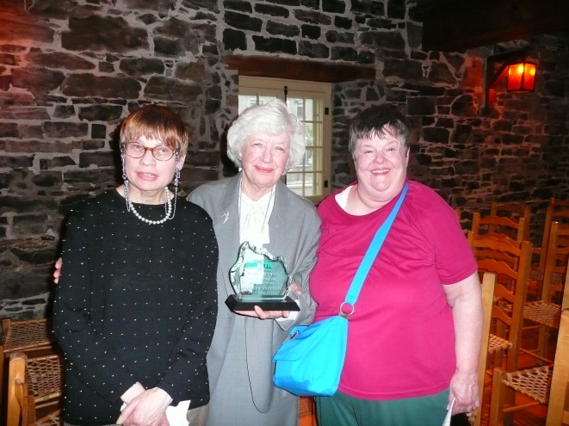
By that time, we were hungry, so we went to our favourite restaurant. Our table was beside the window, and we saw the Christmas decorations on McGill College Avenue and also three policemen on horses!
On the following Saturday, we went to the Placement Potentiel Christmas party. On our way in, I met a friend from the Lakeshore General, and her daughter. We all sat together and had a wonderful evening, a good turkey dinner (and a delicious dessert), music and door prizes. The next day, we went to Denise’s Concert at the Oscar Peterson Hall. She played the French horn in the orchestra. We met her mother and Kinga was there too!
Marina Mazeika
Trip to Quebec
In February, we went to Quebec City by school bus. It was a long drive – three hours. Before we got to Quebec City, we stopped at a Mall, and we had lunch there. We also had a bathroom stop. That night some of us went to a bar for a drink. The next day we went to a Mall in Quebec City and we had lunch. In the Mall, I lost Edward and David, but I found Denis Bertrand in the restaurant. After that, I got on the school bus, to go home. I had a good time, but I couldn’t afford to buy a souvenir.
Denis Bazinet
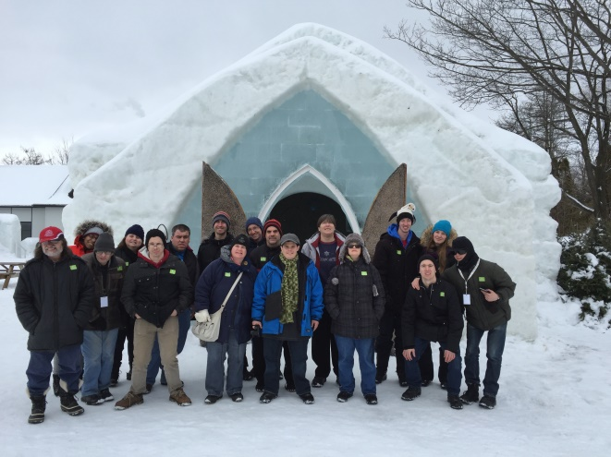
My Hospital Adventure
On February 13th, 2016, I had my first ride in an ambulance as a patient. I had a fall in my bedroom that afternoon. My scalp was bleeding and I couldn’t get up. However, I was otherwise not in pain. Eventually I was able to get to my telephone table and pull the phone off the table to call 911, and get to the door to let the technicians in.
I was in the LaSalle Hospital for two and a half weeks. I am now waiting to go to a new place to live. Maybe I can write about that one day!
It took me a long while to be able to resume my daily activities, to go out and do shopping, etc. My brother is now the person who does my banking when I can’t do it myself. However, I returned to Church two weeks ago and today I went shopping with Kate for the first time in a long while. Kate is my Citizen Advocacy Visitor.
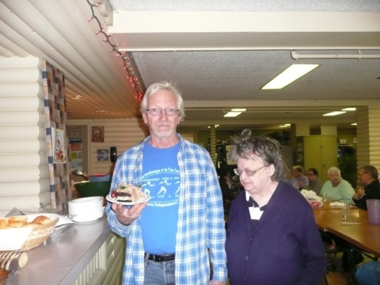
I look forward to the Anniversary Party and to other activities which I hope to attend.
Sue Crotty

20th Anniversary Greetings
Comitas is 20 years old! On behalf of the AVATIL Board of Directors I would like to congratulate all the members, Friends of Comitas and AVATIL staff on this, the 20th anniversary of the birth of Comitas. This is a great achievement. I remember how more than 20 years ago, a hard-working group of parents and volunteers turned a dream into a reality. The dream was to ensure that the AVATIL friendship and support groups that they started when their sons and daughters were young would continue as they got older and their parents would no longer be there to help them.
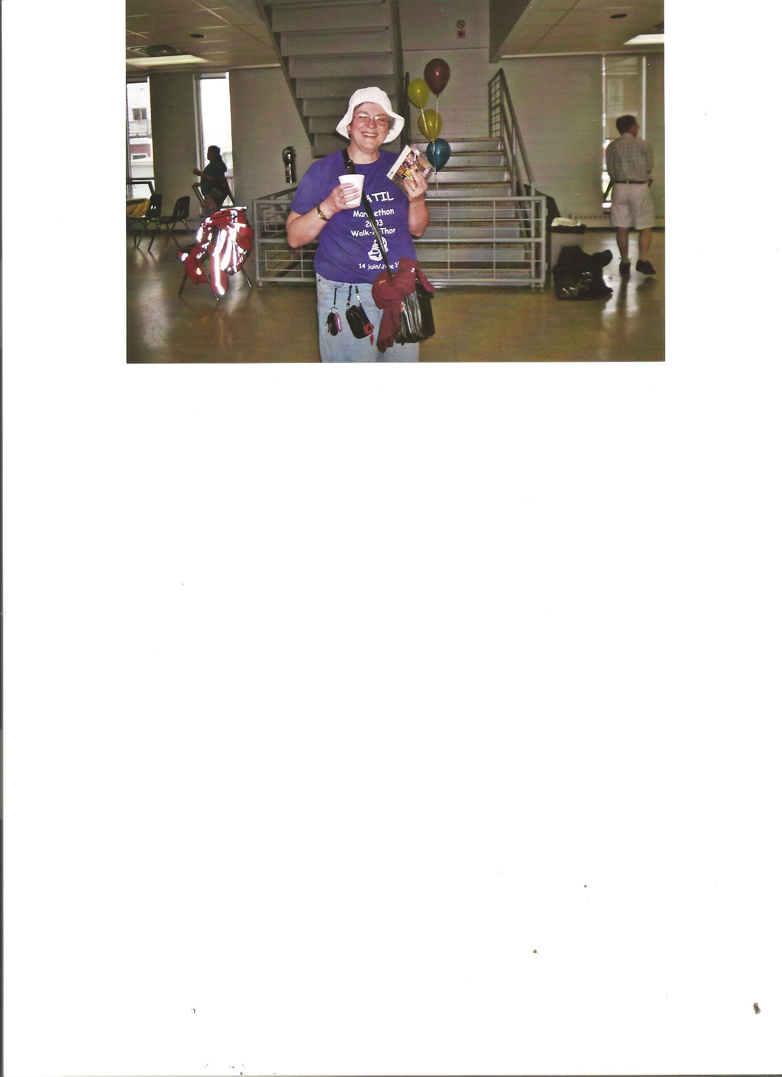
Over the last 20 years I have seen how Comitas has grown into an active group of people who have fun, learn new things together, and support each other. I feel it is the commitment of the Comitas members, as well as the guidance of the Friends of Comitas volunteers and the AVATIL staff persons over the years, that have contributed to the success of Comitas. A special thank-you to current volunteers Maureen Anderson, Denise Desjardins, Sharon Morrison, Elaine Whitton, Estelle Laporte and John Crotty, and staff member Amanda D’Aversa for all their hard work to keep the Sunshiners and Moonlighters going.
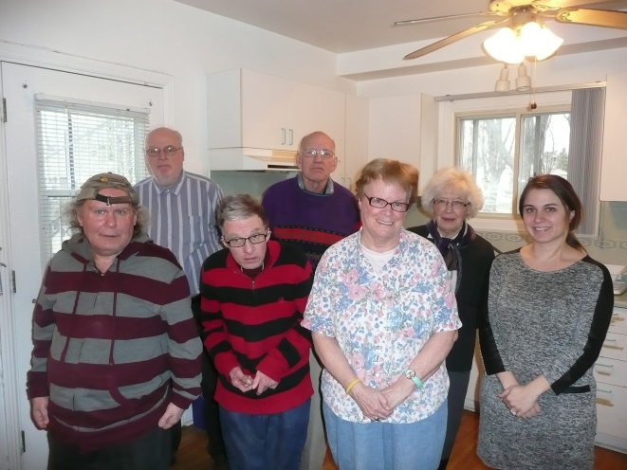
I feel that the founders of AVATIL, who also had the vision to start Comitas, would be very happy and proud of you all! All the AVATIL Board members join me in telling you that we, too, are extremely proud of your success and wish you many more happy years together!
Marjie Rutherford, AVATIL President

Lisa(Master)Hyslop was one of our first Comitas counsellors. Her children, Erika and Bradley, made this anniversary greeting for us.

Almost 20 years ago, I started working at AVATIL, and was given the wonderful job of helping with Comitas. It was great fun to help running the Daytimers, Sunshiners and Moonlighters groups. Conversation always seemed to flow easily, especially over tea and dessert. Some of my fondest memories are the outings we had, going to Upper Canada Village, Christmas dinner at Scores, lunch in an old converted bank, celebrating birthdays at Maureen’s, and of course, the famous Pot Lucks.
Congratulations, Comitas, on 20 fantastic years and heartfelt wishes for many more to come!
Lisa Hyslop
I have enjoyed every moment I’ve spent with you over the past two years, and look forward to many more. I hope that Comitas will continue to be a tight network of people who are always there for each other.

Amanda D’Aversa

Congratulations to all Comitas members on their 20th Anniversary. It is an achievement to be proud of. The retired Quilting Group volunteers send their best wishes for many more years to come. Keep on creating!
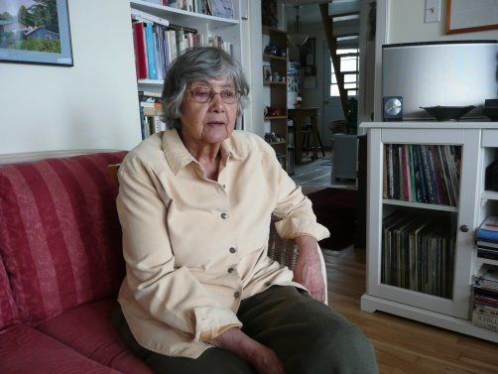
Yvonne Vandersluis

Upon the 20th Anniversary of Comitas, I congratulate all members, volunteers and staff. Comitas has been special from its beginnings. The success of Comitas lies in the enthusiasm of its members to take ownership, to participate in planning, and to live up to the philosophyof friendliness and kindness. I extend my best wishes to all for continued success.
Helen Venneman

Congratulations to all Comitas members, staff and friends on their 20th Anniversary, and very best wishes for the future!
Kinga Lukacs
Congratulations on your 20th Anniversary!
I would like to congratulate all the members of the Comitas community - the clients, family members and volunteers - for their great participation in the Comitas Program throughout the past twenty years. I want to thank you all for your dedication to the program, and I hope that you will continue to participate in this wonderful, supportive community you have built together.
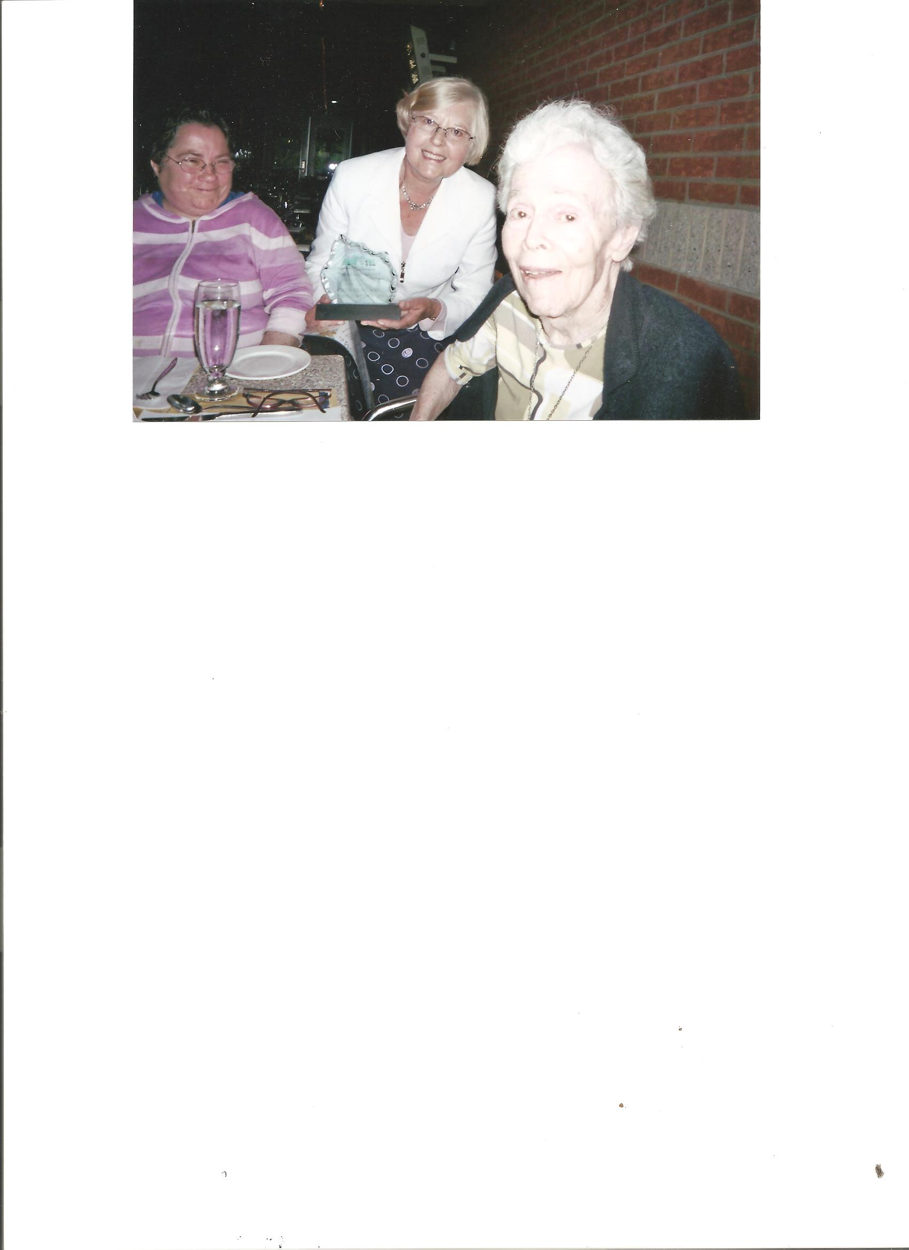
Carmela De Lisi,
AVATIL ,Executive Director

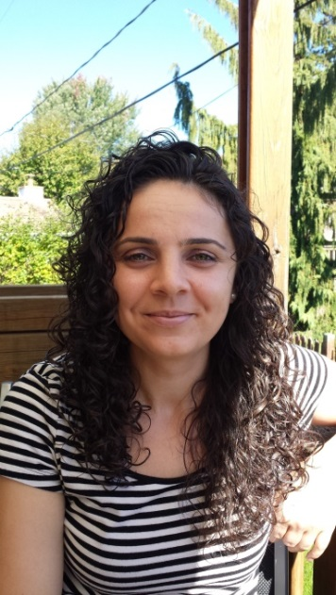
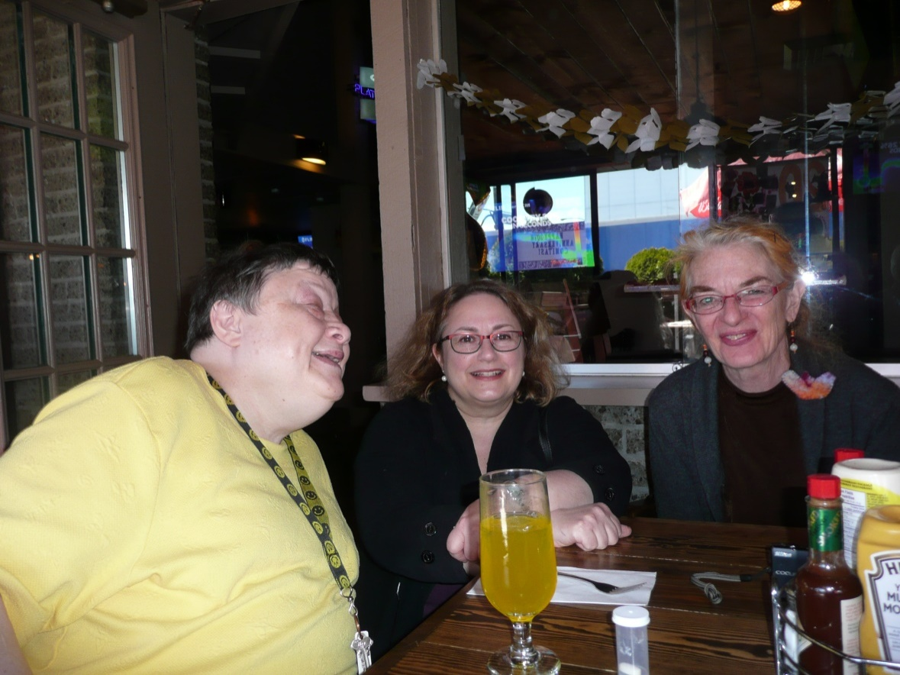

Memory Lane
At Amanda’s suggestion, we asked Moonlighters and Sunshiners to tell us about their best Comitas memories.
Clara Bland: I remember the Chihuly Exhibit at the Montreal Museum of Fine Arts - beautiful glass sculptures. They were amazing and marvellous!
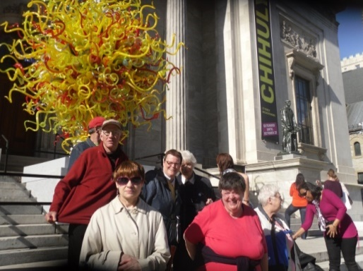
Judy Brown: I’m interested in history, so I loved our visits to the Old Bank in Point St-Charles. One of the exhibitions we saw there was Sharon’s. We had all kinds of pizza!
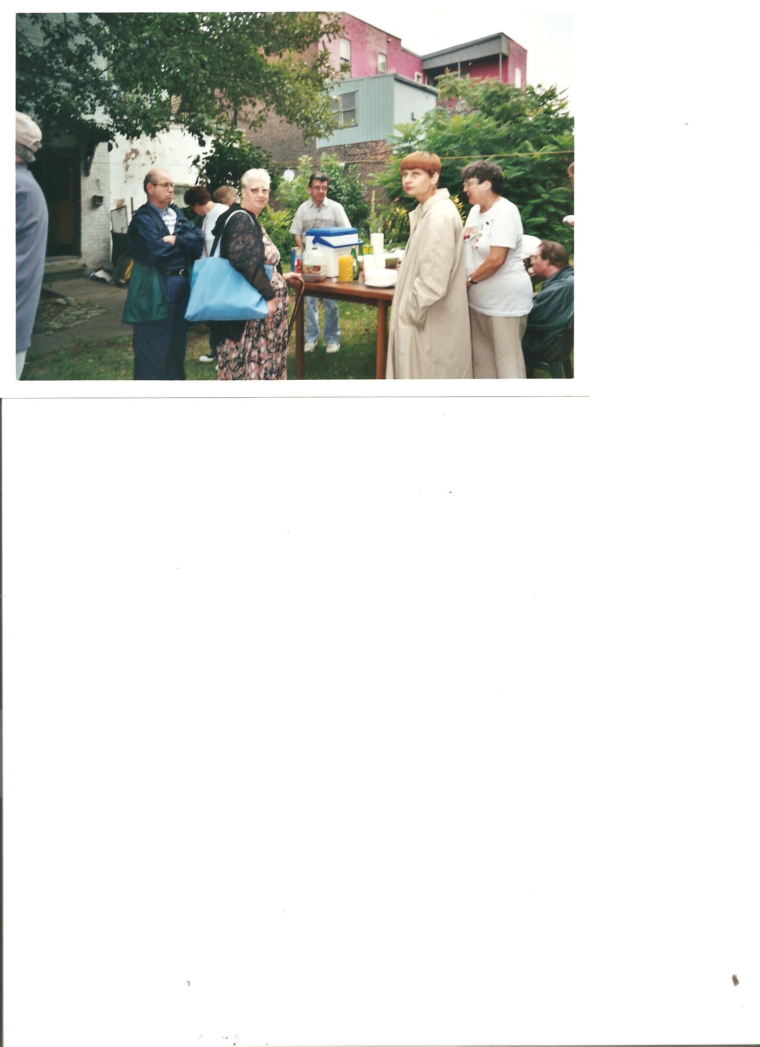
Lena Houtman: My favourite memory of Comitas is the first visit to the Train Museum. We went with Kinga and saw trains of all ages and there was one we could ride on. There was also a nice gift shop. We had a great picnic.
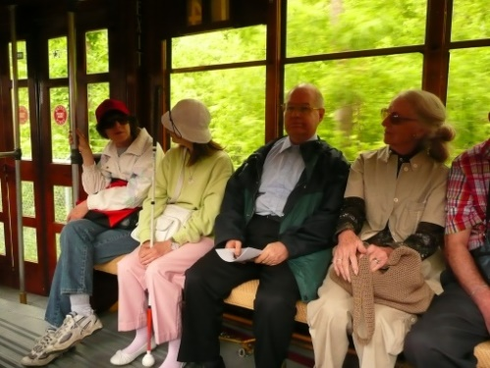
Marina Mazeika: I really enjoyed our 15th anniversary at the Vieille Brasserie. There were wonderful decorations – Denise made them – and great food, catered by Yvonne’s daughter and her son-in-law. There were lots of speeches. Almost all of Comitas was there!
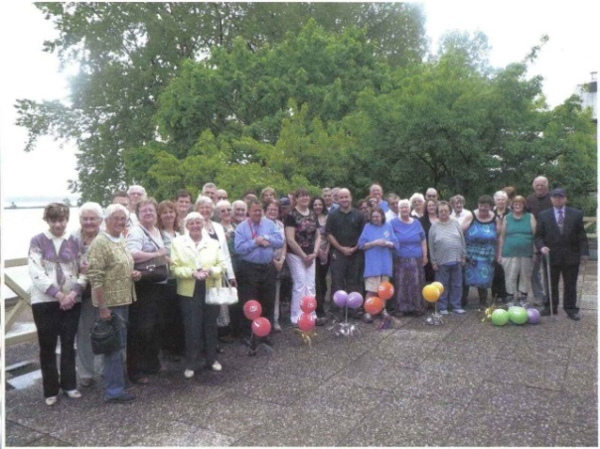
Our 15th Anniversary at La Vieille Brasserie
Petros Carrière: I remember my first Pot Luck about two years ago. It was held at the Chalet. The camaraderie was great and so was the food. I’m really happy to be a member of Comitas and AVATIL.
Charles Nicholls: I really enjoyed the Nutcracker Ballet at Place des Arts, and also I felt the performance of Romeo and Juliet on Dante Street by the young adults was inspiring.
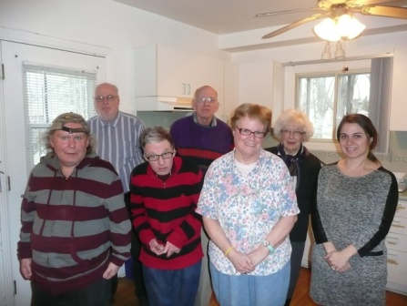
Margo Bray: My best memories of Comitas activities include the visit to the Wax Museum where we met a lot of “celebrities”! The Pot Lucks are important and also our Christmas Parties, and the Art Group picnics. And also the friendship!
Patrick Creeley: One of my best memories is the trip to Toronto, and I also remember pushing David McElligott’s wheelchair in every AVATIL Walk-a-thon he attended.
David Whitton: My best memories include the Art Group and the annual art picnic.
John Neale: I really liked going to the Comedy Fest during our trip to Toronto with Amanda. It was up the street from the Wayne Gretsky restaurant.
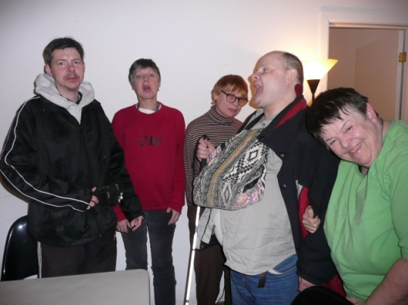
Eric Marin: My favourite activity is the weekly Summer Barbecue, where both the Moonlighters and Sunshiners are able to get together, and get to know each other.
Steven Wright: I enjoyed all of the outings, and especially the trips to Quinn Farm for apple picking, where we were taken to the orchard on a large wagon drawn by a horse. After picking apples, we went back to the huge barn for lunch.
Angelina Sazeirat: Parce que j’aime beaucoup la nature, mes sorties préferées sont les Jardins Botaniques et le Parc Omega.
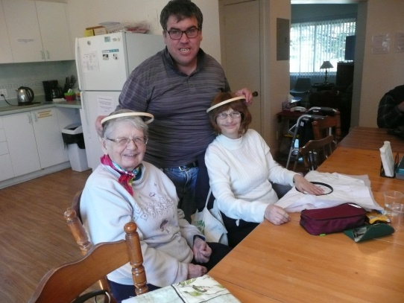
Monique Dorais: Je pense souvent à Suzanne Frenette. On faisait des choses ensemble. Elle était membre de Comitas et une très bonne amie.
James Walker: As the official Comitas Santa Claus, I really like our annual Christmas Party. I get to hand out Christmas presents and see everybody smile. And I also enjoyed the trip to Toronto!
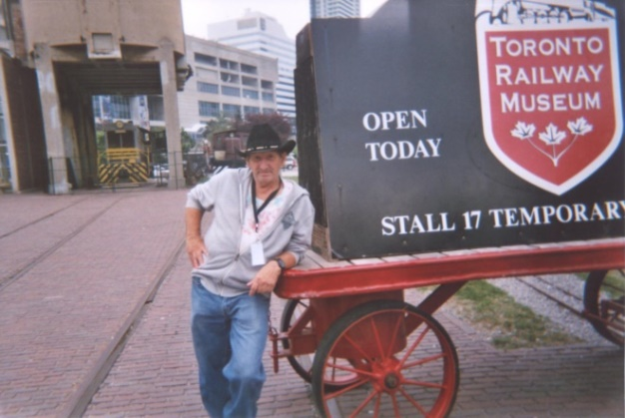
Tracey Monks: What I like best about Comitas are the friends I have made there. We have been together for such a long time and I cherish my friendship with everybody I know there.
My Summer Vacation
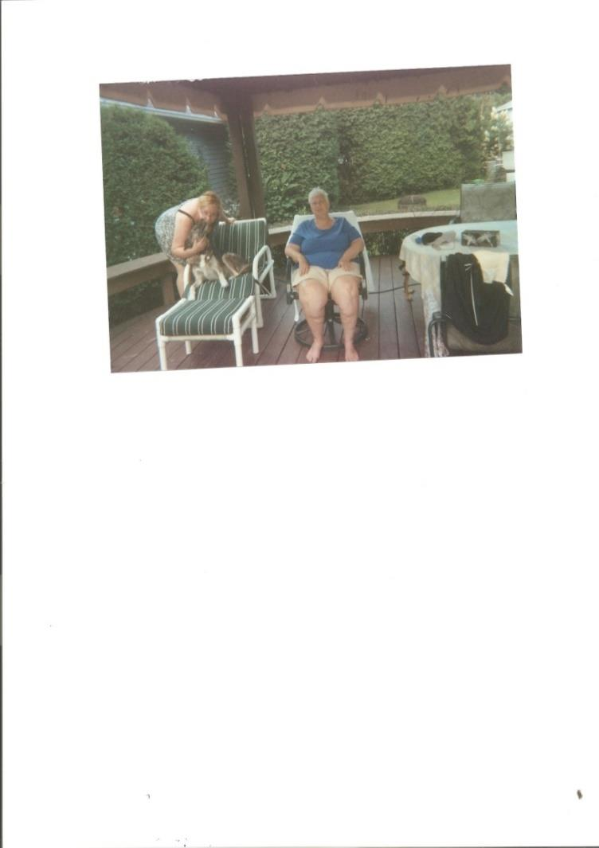
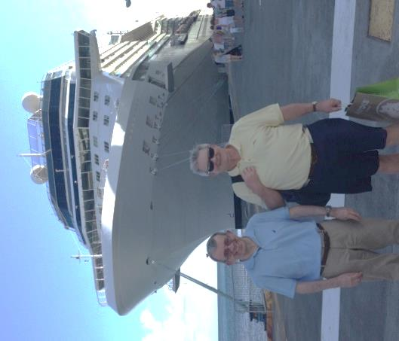

Last summer I spent a week at my brother and sister-in-law’s home in Hudson. They have a beautiful house with a big swimming pool and a hot tub. I went swimming every day. The weather was beautiful. I was glad to spend some time with Keith and Alana.
Judy Brown
Caribbean Cruise – March 2016
To start off, I took the train to my brother Rick’s in Markham on March 2nd. The next day, we had a 2.45 p.m. flight to Fort Lauderdale, Florida. This turned out to be a long adventure. It took three planes to get us there. We finally got to our hotel at
4.15 a.m. the next day, nine hours late!
Friday, March 4th. We boarded our ship, Celebrity Equinox, for our 10-day Caribbean cruise. I had my own room with a very nice balcony, next to Rick and Cheryl’s room on the 12th deck. Our first two days were at sea.
Monday, March 7th. We arrived at St. Thomas. Rick and I explored the town for about four hours. Cheryl stayed on the ship. She injured her foot before we left and we were pushing her around in a wheelchair. Because of this we got VIP treatment!
Tuesday, we were in St. Kitts and took the scenic railway to see the island. This was the old railway that took the sugar cane to be processed.

Steve and his brother Rick
Wednesday was Barbados. We had a taxi driver, Archie, who gave us a tour of the island. One of our stops was an old plantation, St. Nicholas Abbey. Here we watched the sugar cane being pressed into syrup, used to make rum. We didn’t taste the rum, unfortunately.
Thursday and Friday we were in St. Maarten. Half the island is French and half, Dutch. We were just on the Dutch side, in Phillipsburg, the capital. There was a strike on the French side, so we didn’t go there. We didn’t take any tours here and just wandered around the town.
The ship left St. Maarten on Friday night bound for Fort Lauderdale. We spent the two days on board, enjoying ship life and all the good food. There always seemed to be great meals, day and night. We saw the shows and other activities that were available on board.
Monday, March 14th, we docked at 7 a.m. in Fort Lauderdale. We left the ship behind and headed for the airport for our 12 p.m. flight home. All in all, it was a great vacation.
Steven Wright
Cabane à Sucre
On March 19th, a group of Comitas members joined the annual AVATIL sugaring-off trip to Mont Saint-Grégoire.
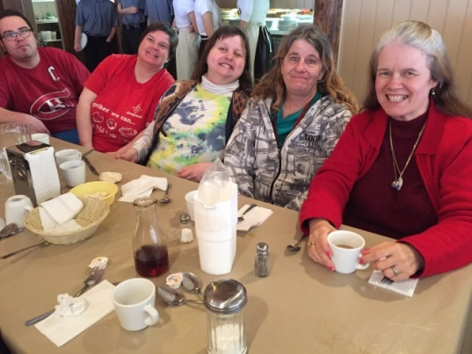
Margo Bray: We went by school bus to our usual sugar shack. Most AVATIL and Comitas clients were there. Marissa, Denise and Stephanie came with us. We arrived at about 10.30 – 11.00 a.m., and when we got in, some of us went for a walk. We looked at the sap buckets, and they were frozen. It was cold and sunny that day, and we dressed up warm. We ate at about noon, and then went on a horse and buggy ride. The cost was included. Some of us bought some souvenirs, then we all got ready to leave. There was not too much traffic and we got home at about 4.15 p.m.
(Thanks to Marissa McLevy for all the photos of the Cabane à Sucre adventure!)
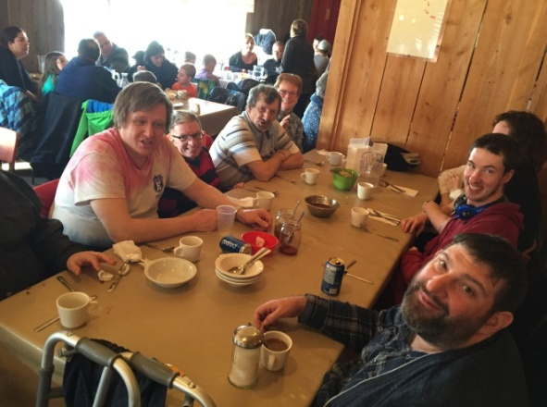
Natalie Kweatkowski: I had a great time at Sugaring Off. I also went on the buggy ride. The horses were galloping. I had maple sugar on a stick. There was dancing inside the chalet and I joined in. I wanted to stay longer, but the bus was leaving. Next time, we should stay for supper.
Denis Bazinet: I had a lot of fun at the Sugaring Off. I bought some souvenirs – blocks with all-coloured lights and a bracelet. I stayed inside the Chalet because it was too cold outside. I had a beer, and then I lined up for lunch. The bus came at
2.15 p.m. and we left for home
Terry Rutherford; I went to the Sugar Shack with AVATIL. We went by school bus. When we arrived, we went to relax; then we went to eat, then some of us went on a horse and buggy ride. And then some of us went to get maple syrup on snow!
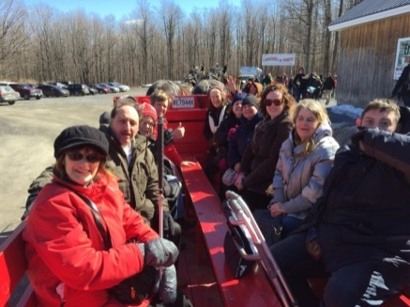
Adapted Transport
My name is Terry Rutherford and I want to talk about Adapted Transport.
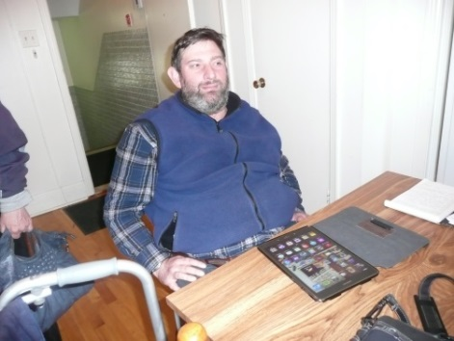When I was young I used to take regular buses. I first applied for Adapted Transport after the year 2000. When I applied, I got denied. Then I applied again and I got accepted in 2008, but it was only for the winter months. After a while I got put on Adapted Transport all year round, summer, fall, winter and spring.
It was my first educational work trainer, Dale Mackinnon, who got me started.
Terry Rutherford
A Trip with the Teapot Members
On a Wednesday afternoon in April, I went with the Teapot members to an exhibition at the Pointe à Callière Museum in Old Montreal. We saw all the artefacts related to Agatha Christie, the famous mystery writer. We had a guide who told us all about her life. We saw a movie that showed the train she took to Egypt for the archeological excavations. I found it very interesting because I like history.
Judy Brown

Mom’s Butter Tart Recipe
Preheat oven to 375 degrees
In one big bowl, mix the following ingredients:
1 beaten egg
1/2 cup brown sugar
1/2 teaspoon vanilla
1/4 teaspoon lemon juice
1/4 teaspoon salt
1/4 cup margarine
1/2 cup corn syrup
After everything is mixed, add between
1/2 cup to 3/4 cup of raisins.
Pour into a dozen mini pastry tarts.
Bake for 20 to 25 minutes
I use store-bought mini pastry tarts, already shaped in a foil tin, either Tenderflake or a store brand. You just need to put them on a cookie sheet for easy transport to the oven.
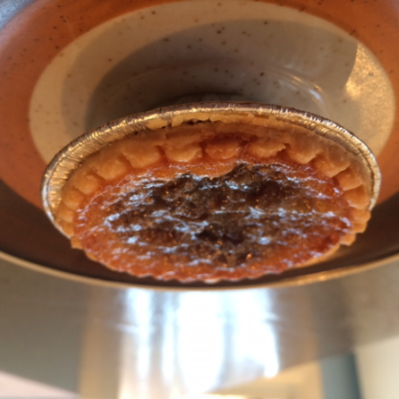
Denise Desjardins
Readers will be interested to know that this recipe was tried out in the Newsletter’s “test kitchen” and served to a panel of judges (aka the art group) who gave the result an A+ rating!

A Conversation with ...
On April 8th, 2016, I sat down with Clara Katherine and John Bland speaking about their mother Fay Bland regarding the origins of AVATIL and Comitas. This conversation took place in Clara’s lovely apartment in Pointe Claire. Clara is the eldest of 4 children. She and her brothers, John, Andrew and Harry were born and raised in Ste. Anne de Bellevue by their parents. Clara says she misses her Mom all the time and thinks of her every day. John noted that Fay was a very energetic and determined person rarely derailed from her goals.

Fay’s vision originated with the need to find proper training, workshops and activities for young people living on the west island and dealing with intellectual handicaps. In its infancy, AVATIL was called the Lakeshore Vocational Projects Association and it came to life in 1972. The building was formerly an Orphanage belonging to the United Church of Canada. The building no longer stands but at the time was located at 1250 St. Antoine Street. Clara was amongst 8 young adults (7 women and 1 man) piloting the program in Lachine.
The program was created to support these young adults and prepare them for the future with training in independent living as well as social skills. Members learned cleaning, cooking, caring for an apartment as well as functioning within a group. This led to a permanent home where the clients could live within the community in dignity. These first clients were to serve as role models for the future groups.

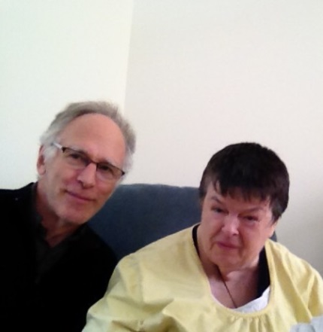
In 1996, Fay and the other mothers established the Comitas program (a Latin word meaning civility or kindness). It was an answer to provide support services for our now senior clients. Comitas was based firstly on the conviction that the most valuable resource that AVATIL participants have is the help that they give each other; and secondly encouraging family involvement in the care of brothers and sisters. This outreach program extends past family members to include volunteers and staff.
Comitas has a very important role in their lives. John noted the values of both programs recognizing their merits over the years. The Comitas group, volunteers and staff are very helpful. Clara and John both feel that they are part of the AVATIL family. These programs have enhanced their lives and they would be very lonely without the group activities.
Fay on speaking to the clients said:
“I would urge you to go on learning, to continue to grow especially in your understanding of people. If you know someone who is unhappy for one reason or another, who is lonely or maybe even a bit hungry, stay in touch. You will know what to do if you think how you would feel. If there is really a serious ongoing problem, let other people know, a counsellor or a friend. If people watch out for each other, we will all be happier and safer.”
On this day I learned firsthand the importance of community living and the extent of Fay’s vision. I thank Clara and John for the collaboration.

Estelle Laporte

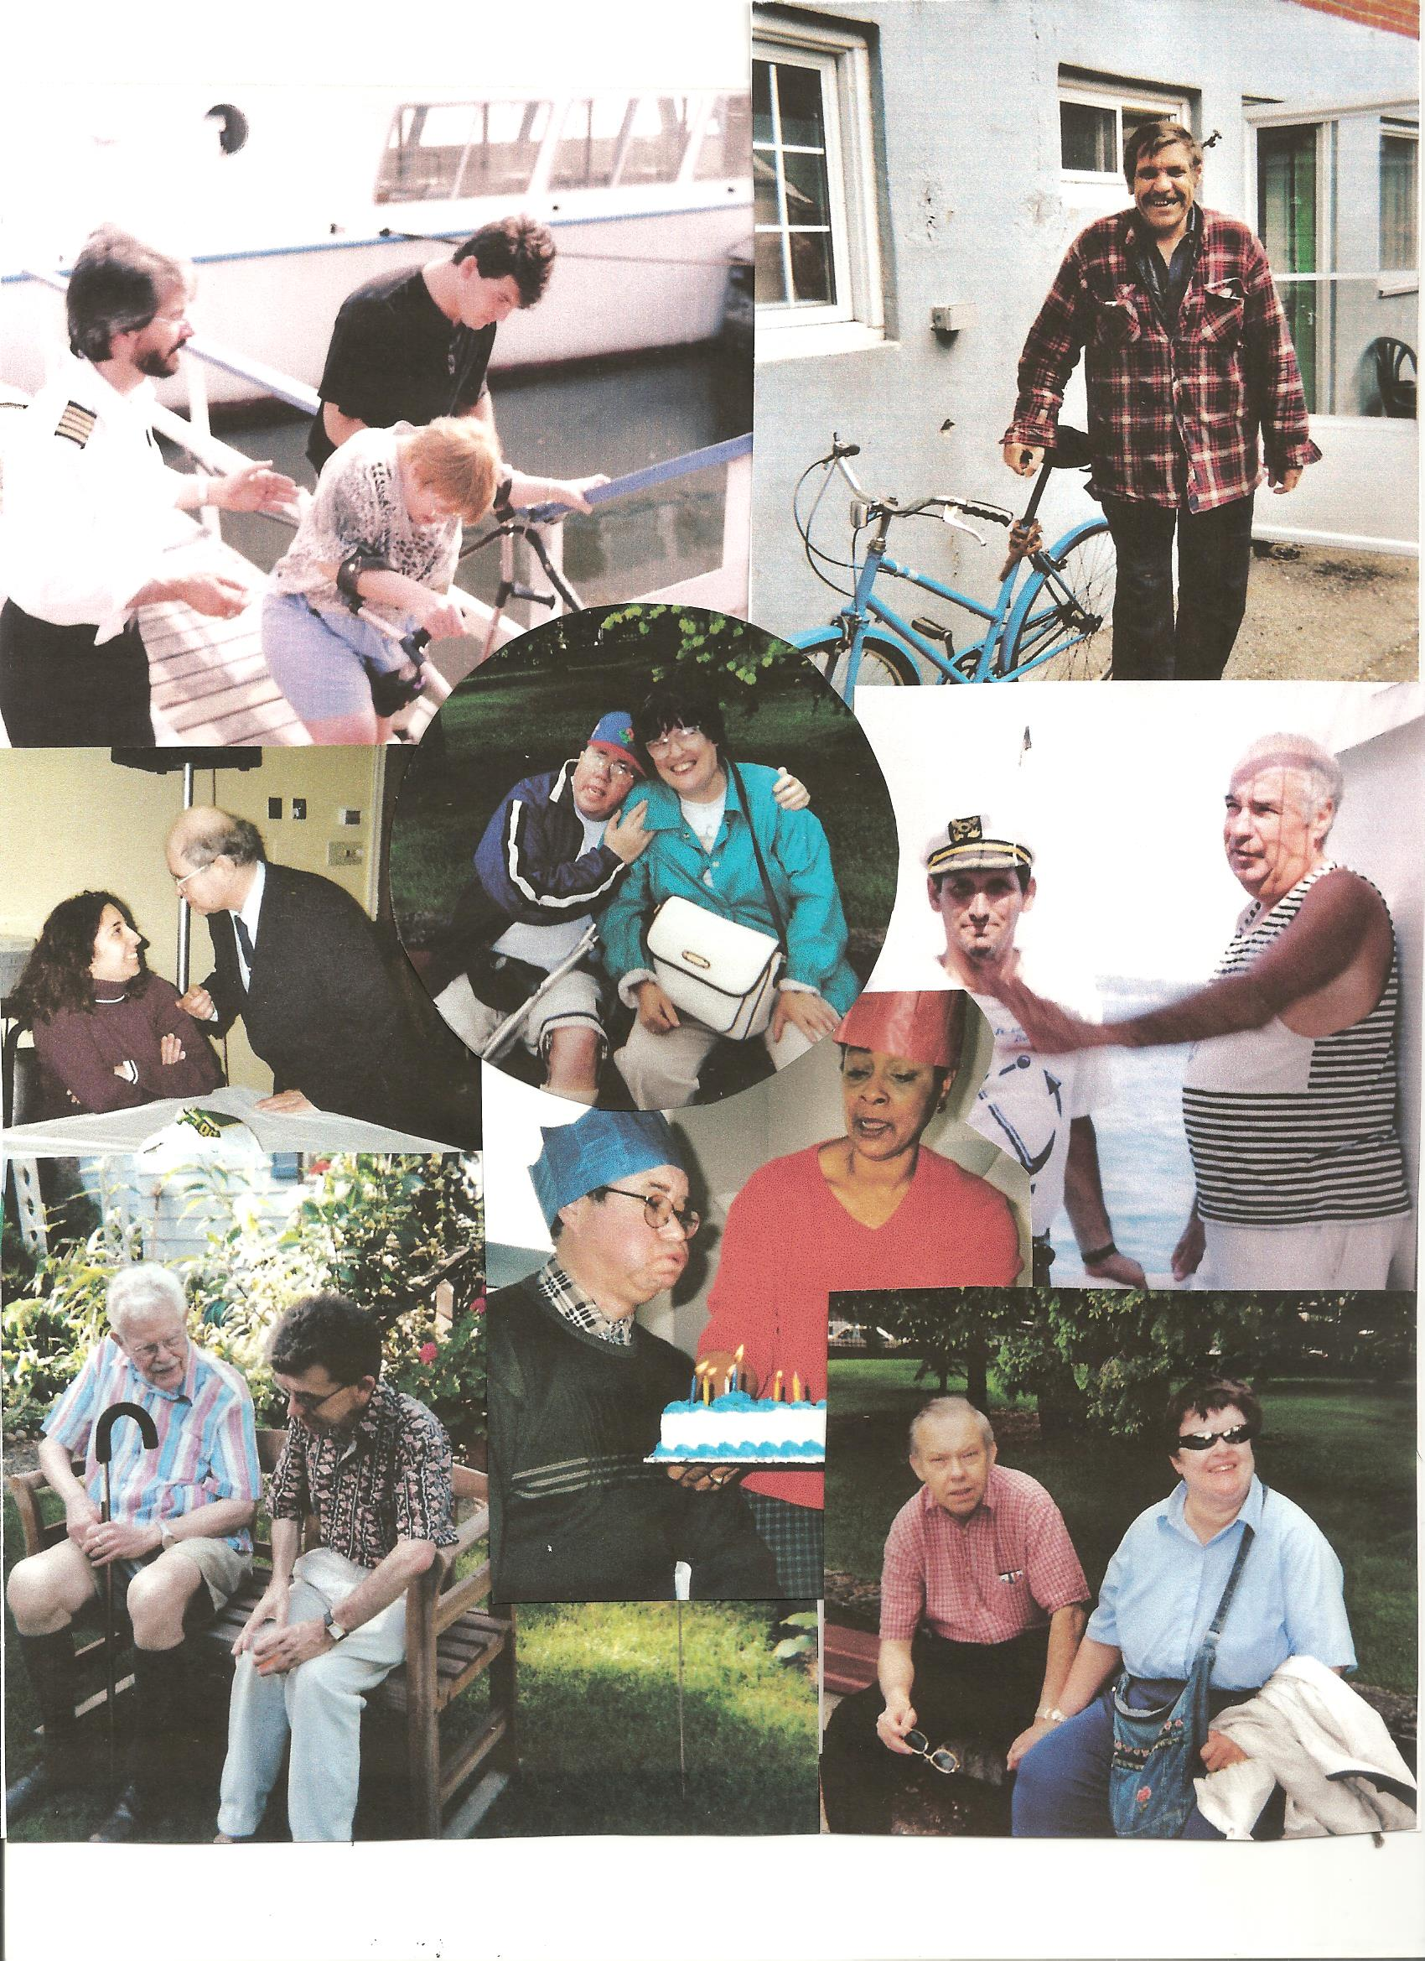
From the top: Sandy Fram getting on board for a Comitas cruise from Lachine to Ste Anne de Bellevue; Robert Vachon arriving for a summer barbecue; Lisa (Master) Hyslop and Gary MacDonald at a pot luck; David McElligott and Meg Van Vliet at the Botanical Gardens; “Captain” James Walker and Peter Cox on the Ste Anne cruise; Gary MacDonald with Carmen Smith at his birthday party; Gerry Cappon and Steve Wright in Helen and Harold’s garden; Ernie Kersgaard and Clara Bland at the Botanical Gardens.
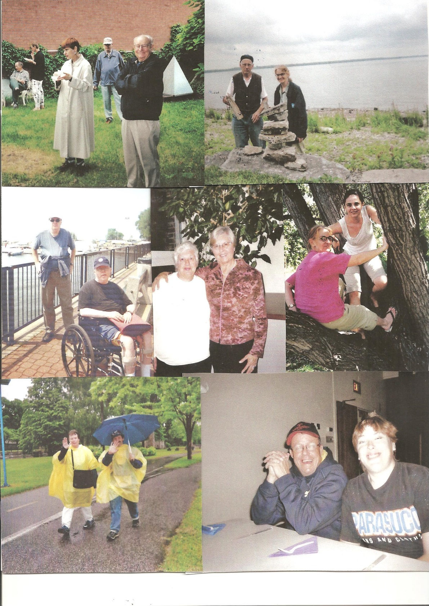
From the top: Marina Mazeika and her father Peter (Patrick Creeley in the background) at a picnic at the Bank; Charles Nicholls and Sharon Morrison at an Art Group picnic; Patrick Creeley and David McElligott on a Walk-a-thon; Judy Brown and Helen Venneman; Sharon Morrison and Kinga Lukacs at the Ile Saint-Bernard picnic; Margo Bray and James Walker at a Walk-a-thon; Jean Hainault and Debbie Ziernicki at a Pot Luck.
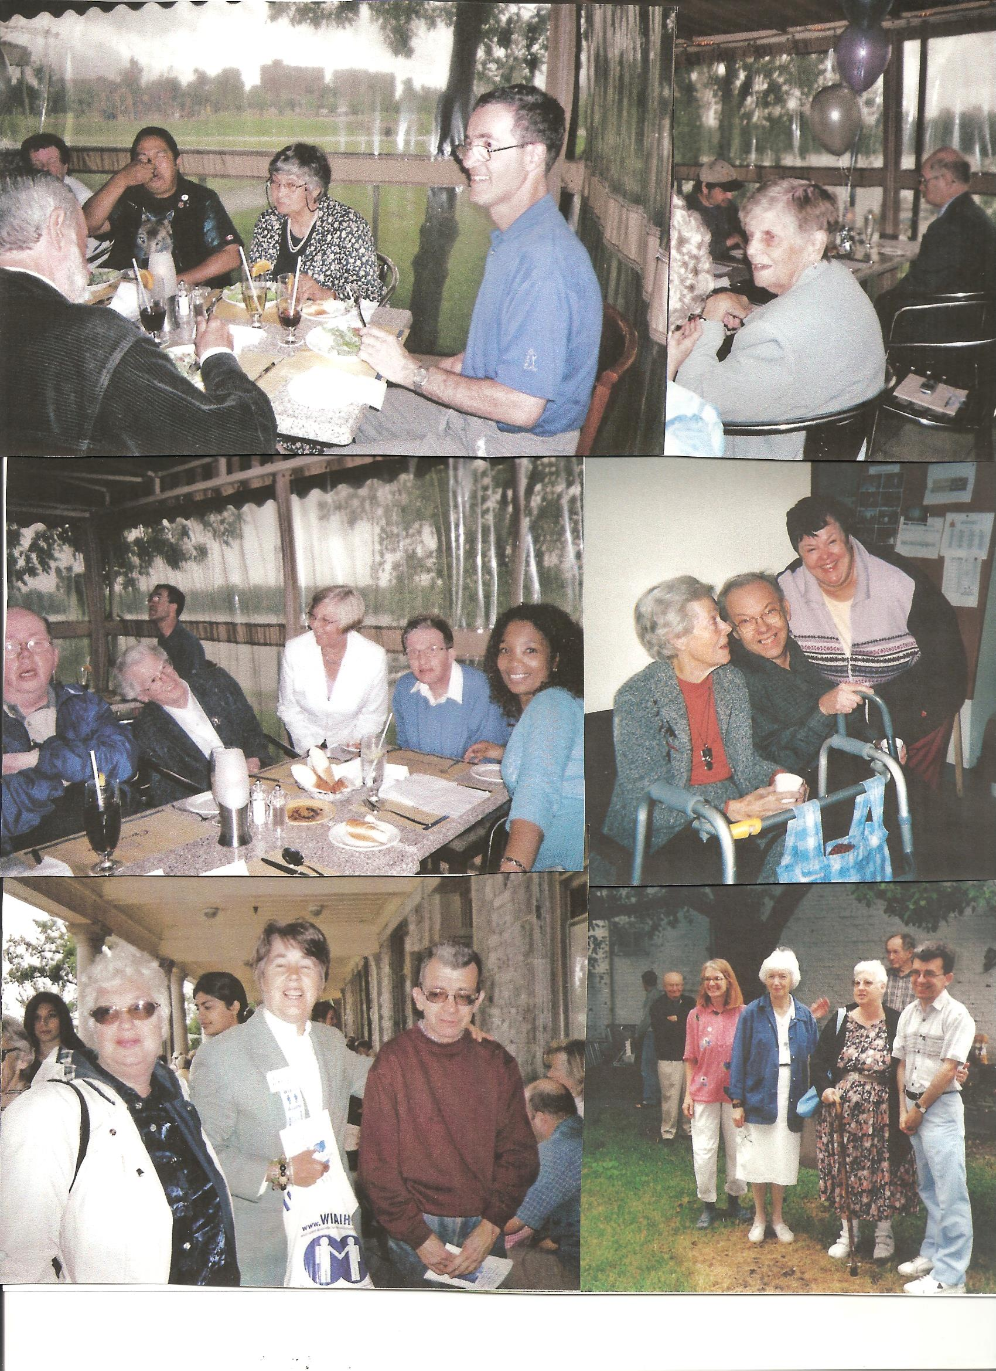
From the top: At our 10th Anniversary celebration: Tuan Vandersluis and his mother, Yvonne, Michel Lemay, Gwen Sample, Gary MacDonald; David McElligott, Elaine Whitton, Helen Venneman, David Whitton, Challette Calbert; Fay Bland, Ernie Kersgaard, Clara Bland; at the West Island Artists show, Stewart Hall; Judy Brown, Amy Cushman, Steve Wright; at a picnic at the Bank: Peter Mazeika, Sharon Morrison, Maureen Anderson, Judy Brown, Bob Cheetham, Steve Wright.
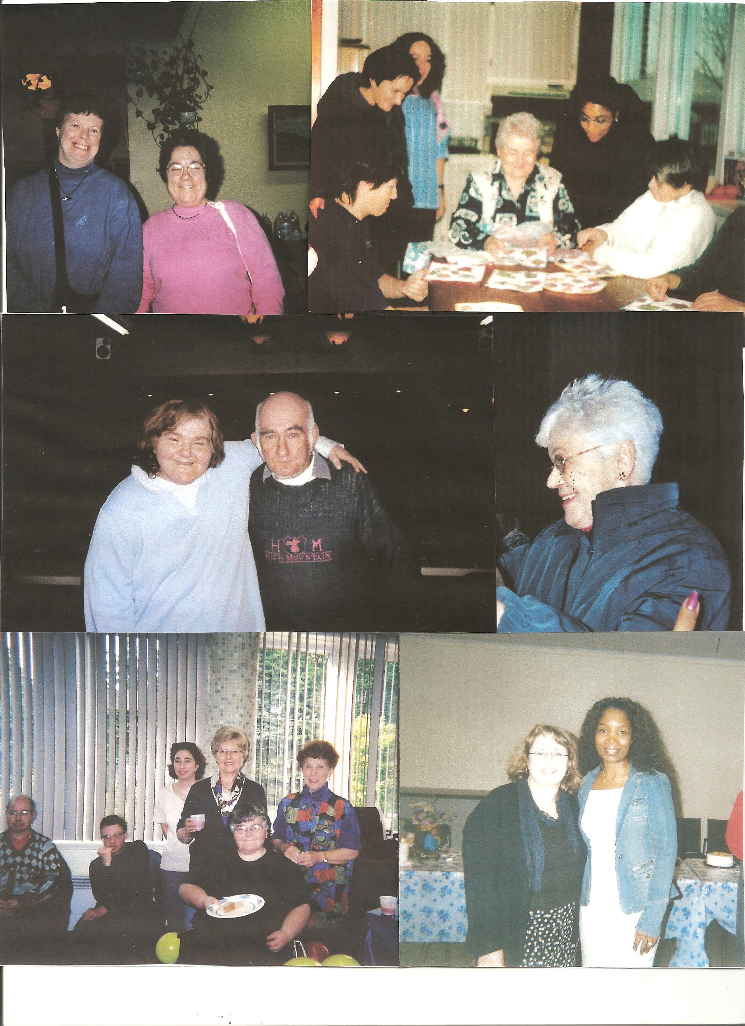
From the top: Margo Bray and Leanne Holland at a Pot Luck; at a Quilting meeting, Debbie Zeirnicki, Martina Torchia, Denise Maroun, Marie MacGregor, Carmen Smith and Monique Dorais; Linda Tucker and Peter Dowden at a Christmas dinner; Gen Steventon at a Pot Luck; Gary MacDonald, David Whitton, Lisa (Master) Hyslop, Helen Venneman, Linda Tucker and Linda’s mother, Marge, at Linda’s birthday party; Carmela De Lisi and Challette Calbert at a Pot Luck.
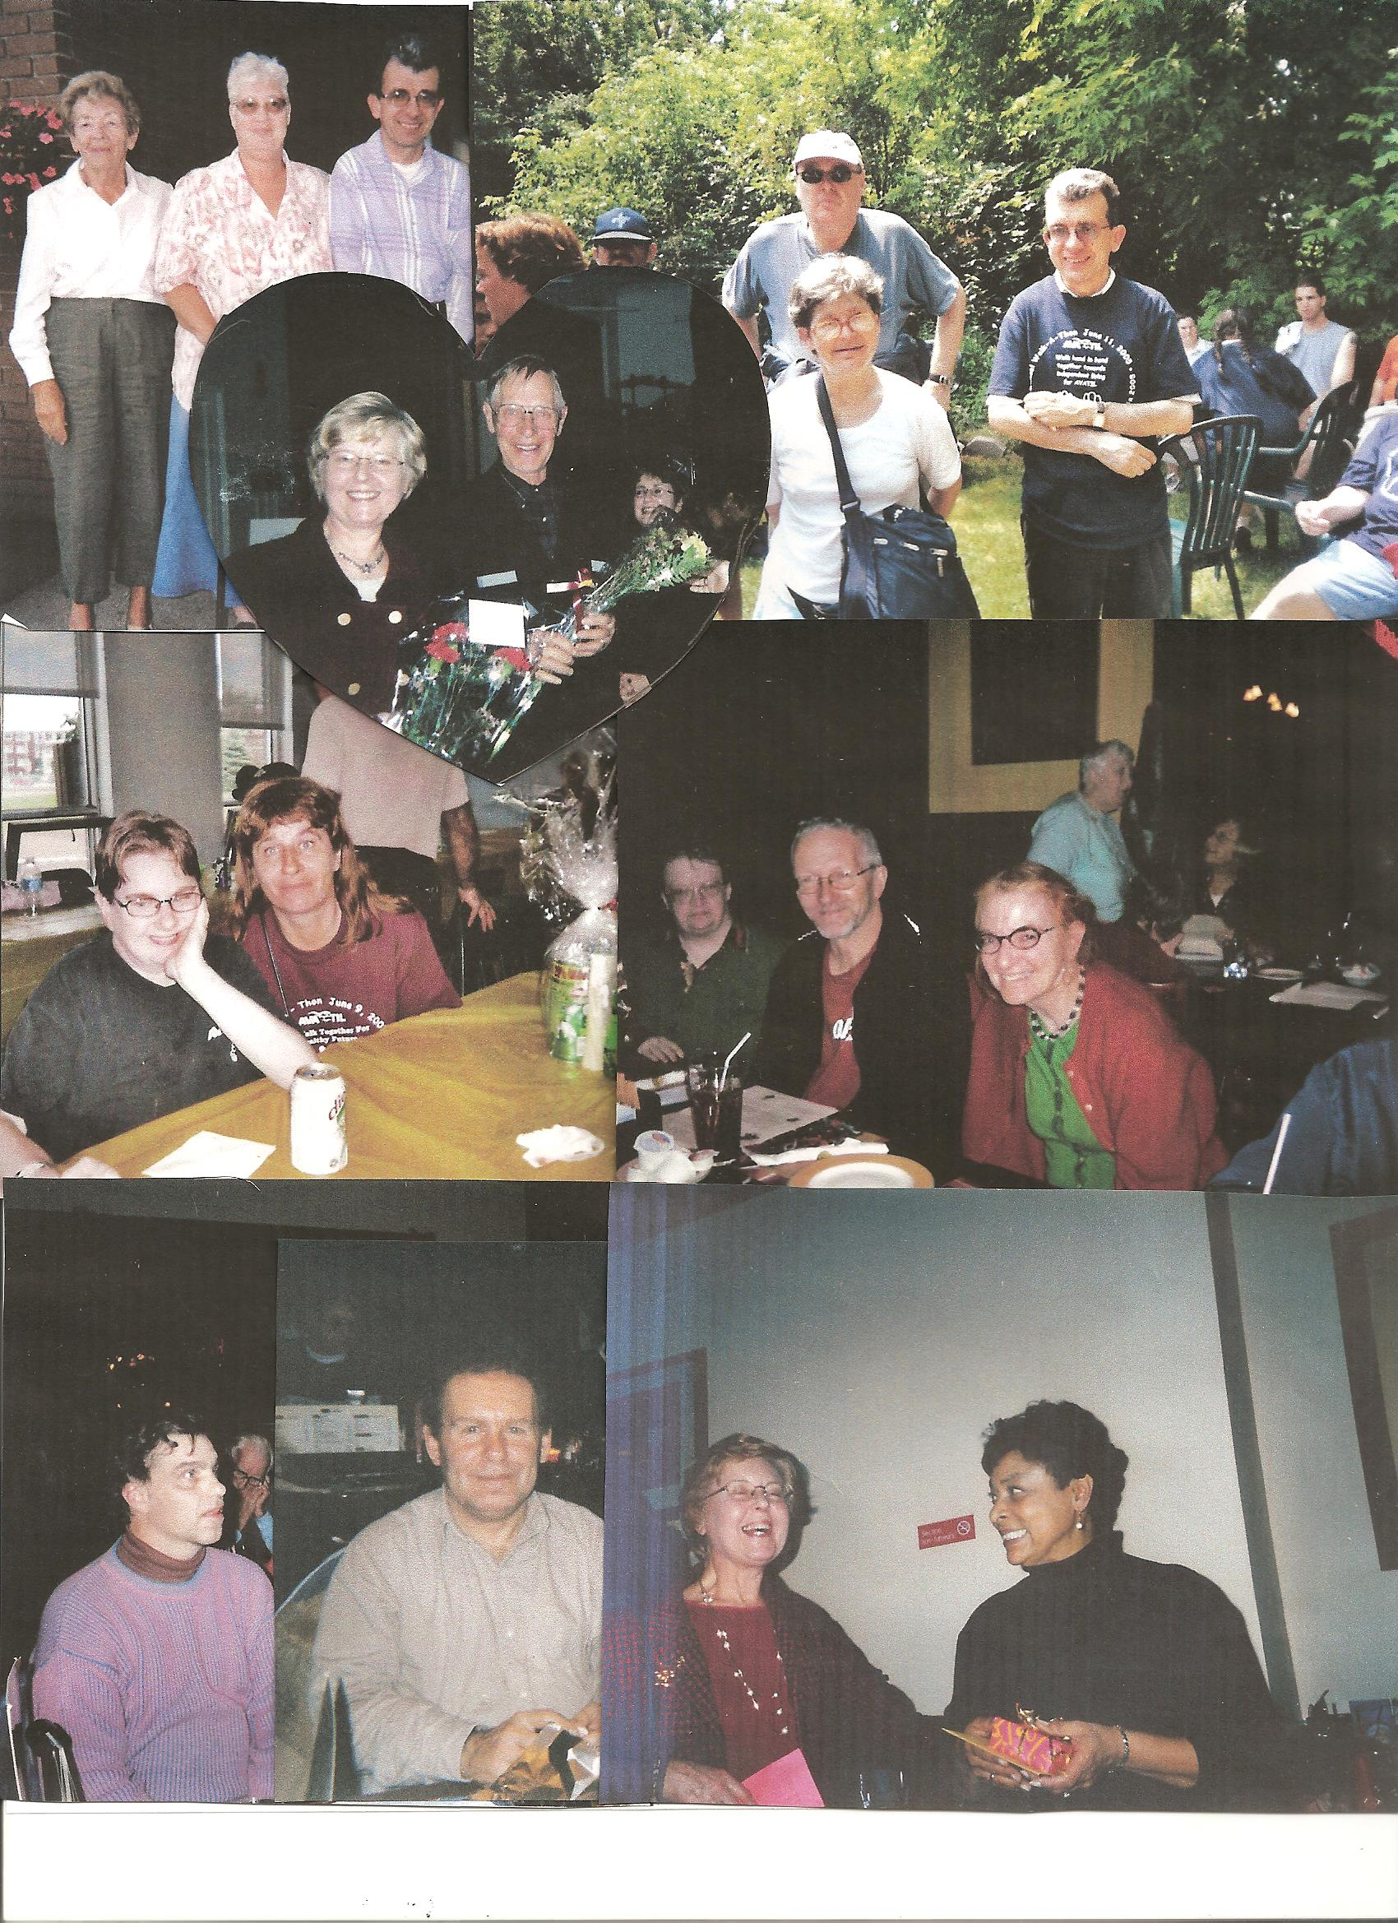
From the top: Peggy Wright, Judy Brown, Steve Wright, Patrick Creeley, Lucie Gingras, Steve Wright in the AVATIL garden after a Walk-a-thon; Helen and Harold at Helen’s retirement party; Casey Burrows and Natalie Kweatkowski at a Walk-a-thon lunch; Sue Crotty and her brother John, and Sharon Morrison at a Christmas dinner; Graeme Couture and John Neale at a Pot Luck; Helen Venneman and Carmen Smith at Carmen’s retirement party.

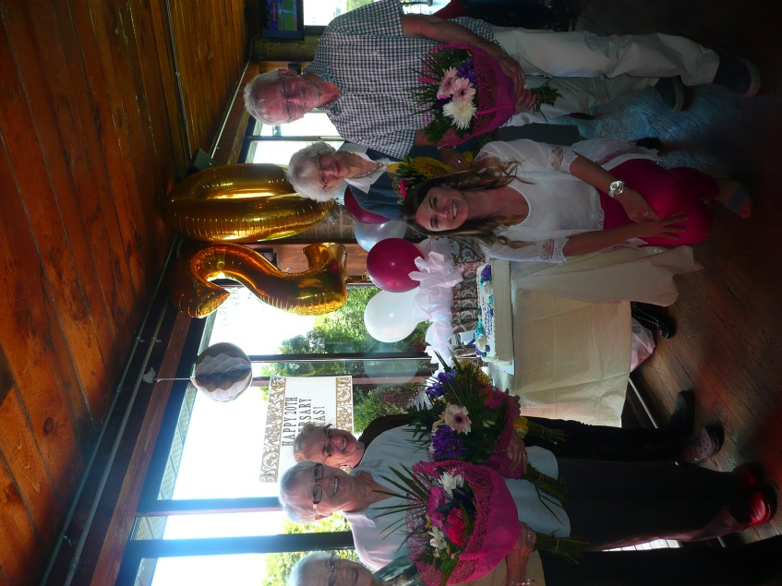
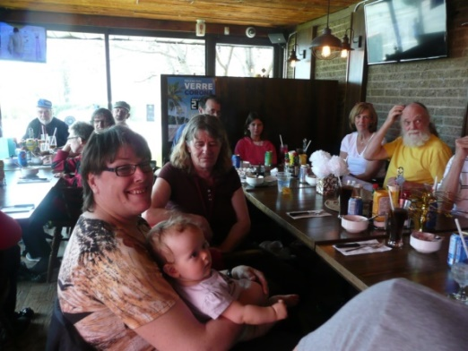
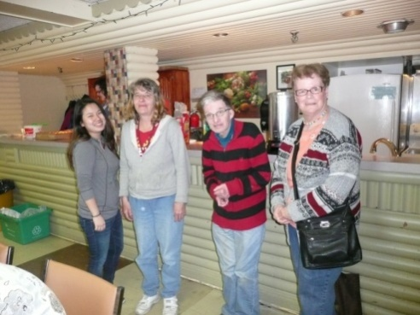

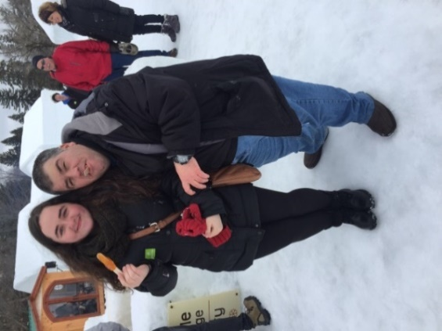

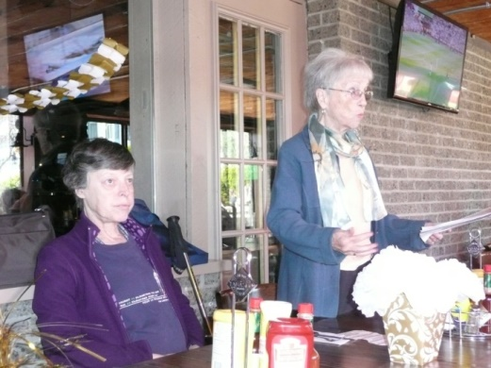

The editor would like to thank all the contributors to this special anniversary edition of the Newsletter,not only for the many articles included and the memories and photographs shared, but also for the expert technical help in preparing it.
Maureen Anderson

