**Comitas Newsletter No. 40, December 2019**

*Comitas is a group of clients over the age of forty. It has been successful in bringing friends and families together by organizing enjoyable activities and outings. It is an important part of AVATIL. Brothers and sisters, friends and others are invited to join Comitas to help support, enrich and celebrate with us according to their interests and time constraints. They may also serve as advocates.*



**The 40th Issue of the Newsletter!** The Newsletter began in May 2000, and has been issued every May and December since then. The articles and stories have been contributed by our members, and occasionally by family members, staff and volunteers. We have had regular columns – for example the Profiles, written by Helen Venneman, our first Comitas Coordinator, and illustrated by her husband Harold Wubbolts, until they retired. Then in 2011, we started the Interview column, in which Comitas members conduct the interviews. These interviews are still going on. We’ve had articles and stories about our lives, our interests and activities. And we’ve even had an ongoing recipe column! Reading the Newsletter and contributing to it, have helped us to share experiences, and to get to know each other better.

To celebrate this milestone, Helen and Harold were invited back to Comitas for lunch with old friends, and for the interview, which follows. *Maureen Anderson*

**Interview** On October 25th, 2019, our dear friends Helen Venneman and her husband Harold Wubbolts were interviewed for the Newsletter by Angelina Sazeirat, a member of the Sunshiners Group.

**Angelina**: *Helen and Harold, you have both been such an important part of AVATIL and Comitas. You are members of our Comitas family! How did Comitas begin? Helen, I believe you were the first Coordinator?*

**Helen**: Yes, I was the first Coordinator. We had a meeting at AVATIL including all client members over the age of 40. We wanted to know what the members thought Comitas should be. The early days were wonderful. The first members didn’t want to be told what to do –they had their own ideas.

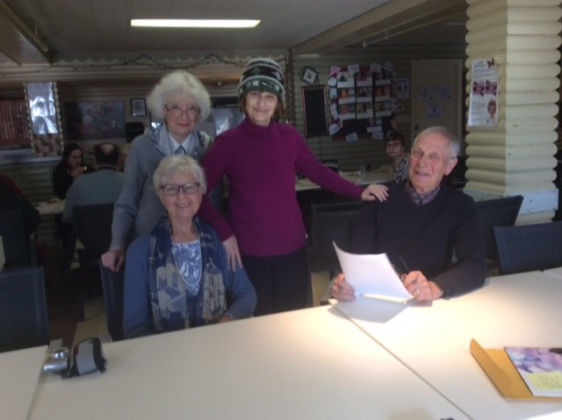

We had a small apartment for meetings. Parents came too; they were very involved, especially at potlucks. And I shall always remember the potlucks at the old Latvian Centre on Provost.

**Harold**: We would take out the tables and chairs, arrange them before the potluck started, and then put everything back afterwards. The furniture was kept in a special room at the back. I remember that Mrs. Sample organized the clean-up and everyone gave a hand. And I also remember that James Walker was a great help at these meetings, and Patrick Creeley, too.

**Angelina**: *Those must have been nice days*.

**Helen**: Yes. There was a parent group of volunteers who brought wonderful home-cooked food; it was like Sunday supper at home!

**Harold**: We were so many at the potlucks that we had to call out table numbers so that one group at a time could come up to fill their plates.

**Angela**: *You were a whole community!*

**Helen**: Yes. In addition to Fay Bland, our founding member, I remember Jacky Morin. It was Mrs. Morin who prepared our request to the Federal Government for funding. We needed money to start up Comitas. Another involved member was Mrs. Peggy Wright, Steve’s mother.

**Harold**: And Helen drafted me! There were many parents involved at that time.

**Helen**: Yes. Marina’s parents, Erika and Peter Mazeika. And Paul Babarik, a psychologist who was invited by Peggy O’Byrne, then Director of AVATIL. The parents were concerned about the future of their aging children. They wanted an ongoing support committee to address the problems they would face as they become older.

**Harold**: At the beginning, a special event was organized to introduce the new Comitas to parents, AVATIL staff, and volunteers, etc.

**Helen**: It was a conference. There were reporters from the media. Many people heard about it and I remember afterwards people asking me about this new venture.

**Angelina**: *These must be special memories. Please tell us about the early activities and outings.*

**Helen**: I think the first outing proposed by the new Comitas members was a trip to Ottawa. We all stayed at a Bed and Breakfast. It was very enjoyable, and it reminded me that Fay Bland used to say “we have to build memories”. There were many trips to follow, for example, bus trips to Upper Canada Village, boat trips to Ile St. Bernard in Chateauguay on the South Shore*,* visits to the National Train Museum and many others.

**Angelina**: *Who chose the names Sunshiners and Moonlighters?*

**Helen**: The Comitas members themselves chose the name**s**: Sunshiners because of the connotation of happiness, and Margo and James came up with “Moonlighters” because they liked the evening activities. There was also a Daytimers group for members who had some mobility problems. I believe there were about 10 to 12 members in each of the sections.

**Angelina**: *When did the potlucks begin?*

**Helen:** The first potluck was held in our Fort Rolland apartment. Furniture had been given to us by Mrs. Joan Dougherty who chaired the AVATIL Board of Directors at that time.

I also remember that, at first, the apartment owner was uneasy about renting the apartment to us – he didn’t want us to “hang around”, but I told him our members would behave properly, and years later when we moved, he agreed that we had been good tenants.

**Angelina**: *The Profile section was an important part of the Newsletter.*

**Helen**: We did the Profile section in the Newsletter so that members would get to know each other better.

**Harold**: I like to draw and I loved doing the drawings for the Profile section.

**Angelina***: Harold, I’m told that you were a great Comitas volunteer. In addition to the Profile sketches, you were a good auctioneer when we had “garage sales” to raise money for Comitas activities.*

**Harold**: Concerning the auctions, we asked everyone to donate anything useable to one of our potlucks – pots and pans, clothing, etc. to put on the table to be sold. It was fun. The bidding started when there were items left unsold. Sometimes there was “downward” bidding and many of the items were sold for pennies. But everything on the table went home with someone. And that included food, a tradition that continues today: any leftover food at a potluck is taken home by clients.



And as always, volunteers and clients pool together to tidy up afterwards, now at our potluck home at the Teapot, just as it started at the Fort Rolland apartment, and continued at the Latvian Centre and the Chalet in Lachine.

**Angelina***: In 2006, you jointly received the Fay Bland Award. We were all so happy for you!*

**Helen**: Yes. It was a great honour.

**Harold**: And we didn’t know about it until we were called up to receive it at the Annual General Meeting. There were quite a few telephone calls beforehand, though, to make sure we would be coming to the meeting!

**Helen:**I recall it was Judy Brown who suggested the Memorial Plaque.

**Angelina***: How do you see the future of Comitas? Do you have any thoughts for our members?*

**Helen**: Comitas seems to be going well, and as there will always be a need for members to meet friends and get together, Comitas will continue and thrive.

**Harold**: I think Comitas should reach out for committed volunteers so that it will continue to draw more members. I recollect volunteers like Marie McGregor who was in charge of the quilting group; and there were other activities like the cooking group. And perhaps more physical activities would be helpful like regular walks, or biking or swimming. A monthly activity, for example watching a baseball game with friends over a hotdog or two, especially events that do not cost much, would also be enjoyable.

**Editor**: *Helen, Do you remember the poem “Helen of Til”? Who wrote it?\**

**Hele**n: Of course I remember it. It was written by Paul Farley, and his mother.

**Angelina**: *Thank you both for this interview.*

**Helen**: You are most welcome. It was a pleasure.

**_______________________________**

*\*The poem is on the last page of this issue.*

**Two Summer Concerts** The first time I ever went to a Mystery Concert was this summer, June 15th Denise was in the orchestra and she and some other members were suspects in a murder mystery. The audience members were the detectives. In between the music selections, there were clues to the mystery shown on a large screen. Some of the orchestra members wore clothes to identify them as suspects, and at the end of the concert, the audience members had to submit their answers on a form. There was a prize for the winner. Denise was a suspect, but she was not the guilty party!



The next concert was at Place Desjardins, in the large court of the mall centre. It was jam-packed and the music was wonderful. Denise was in the orchestra and we sat with her mother, and met her sister Carol, who was taking pictures.

After the concert, we went to “Three Amigos” for supper with Denise, her mom and her sister, and some members and friends of the orchestra. We had sangria, and a wonderful meal, and everyone had a great time! *Marina Mazeika*

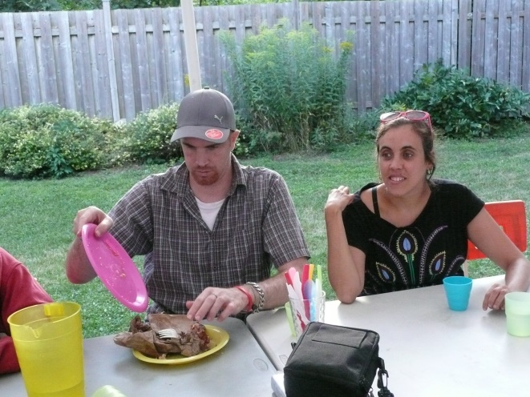

*Tim with Tiffany, on his birthday*

**My Trip to Peru** This August, I went on a trip back-packing through Peru. I did lots of different activities, such as surfing, dune buggying, sailing, mountain biking and visiting the ancient ruins of Machu Picchu. I had never done any of these things before, but I’m very grateful I did. This was all incredible, but one of my favourite parts of Peru was the gastronomy. All the food there was incredible and very cheap; we ate at the 8th best restaurant in South America for the equivalent of about $30 each. It is different from how we eat here: lots of corn, fish and even different meats like alpaca.



Backpacking meant that we stayed with other travellers from all over, on similar trips. Making new friends and learning about their lives was fascinating. I loved my trip: although it was not luxurious, the memories, new experiences and knowledge gained are priceless! *Collin Dobie*

**Art Class Memories** I took a look back at the art class – how delightful it was. From the start in 2003, the group always came up with fresh takes on art. Collage went up from the page, Christmas cards had a storm of white paint snowflakes. We made Hallowe’en masks of Elvis and Madonna (and Stockwell Day!) and cheery little jack-o-lanterns.

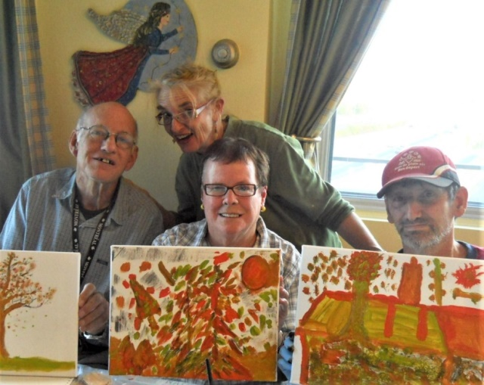

We drew and painted with gusto. We glued every collage known to man! Leaves and lacy, glittery valentines. There was always something to talk and laugh about – we even sang . . . The class was united in our love of Maureen’s cookies! Speaking of sweets, we’ll still be making very colourful Christmas cookies this December! *Sharon Morrison*

**Our Trip to the Dominican Republic** The flight was a bit rocky but we landed safely and everyone yelled “YAY”! They offered us a fruit drink and a cookie.

They showed Debbie and me to our room but there was only one bed, so we told Collin and Erin and they arranged to have our room changed to the first floor which was better for us.

We changed and relaxed until 6.30 p.m. and then we had dinner. Debbie and I went to the show, and then we got lost, but a gentleman from England told us how to get to our room. We missed the 10.30 p.m. curfew, but Collin forgave us. Debbie and I shared a beer and we both smoked and went to bed around midnight.

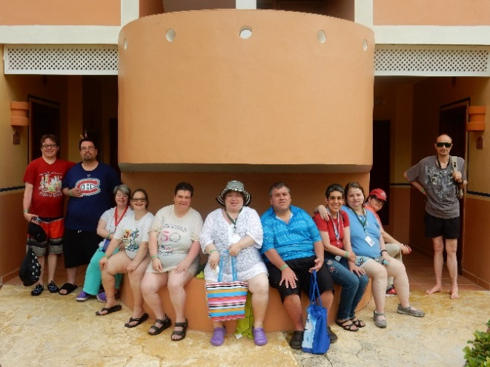

We got up in time for our 9 o’clock breakfast. It was good. Then we went to the pool. It was fun. There was a bar right in the pool! They served alcoholic beverages at lunch and supper. Sometimes I had a beer, and sometimes sangria.



I met a tourist who spoke to me in Russian. I used to be able to speak it, but I can’t any more. But I do understand it.

The whole week was fun, but it wasn’t long enough. Two weeks would have been better. We all had fun. I was so sad to leave that I cried on the last day – I wanted to stay!

*Natalie Kweatkowski*

**My Therapy Angel** After my accident in January, I needed to have physiotherapy for my wrist. The therapist who looked after me at the Lakeshore Hospital was Joann Lyttle. We did exercises like pulling and stretching, pushing the hand against a wall, and whirlpool treatment, etc.

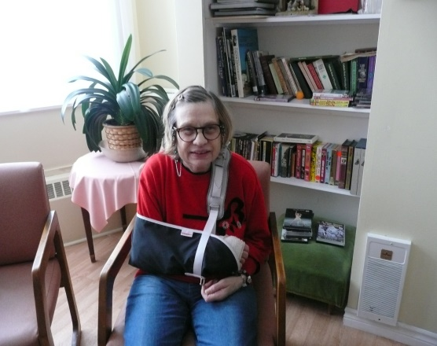

The treatments started in April, and ended in mid-September. My wrist feels much better now, and I am grateful to Joann for helping me. *Marina Mazeika*

**The New Champlain Bridge**  On a fine day in September, Susan and Ken invited me to take a trip over the new Champlain Bridge. We drove to the South Shore, and over to the new Champlain for the trip home. The bridge is white, and very modern. There are two towers on the east end of the bridge, and two on the west side. The cables are extremely large at the base, and become narrower towards the top.

On a television program about the old bridge, I noticed that some barn swallows had built a nest underneath the edge of the structure.

In contrast to the new Champlain Bridge, the old bridge is dark. The new bridge is like a walk into the future – it is so elegant. It reminds me of a white swan.

Maybe the best way to view the new bridge is to be in Verdun, on LaSalle Boulevard, looking southeast. *Charles Nicholls*

**Recipe Corner** On the 25th of April, 1915, soldiers of the Australia and New Zealand Army Corps (ANZAC) were a part of the allied campaign that landed on a beach on the Gallipoli peninsula in Turkey. The attempted invasion was a disaster, and eight months later the surviving troops were evacuated. It was the first time the troops of Australia and New Zealand fought under their own country’s flag rather than under the British Union Jack.

The 25th of April, ANZAC Day, has become the day when the people of Australia and New Zealand remember the bravery and courage of their soldiers in all wars, and remember those who died.

During the battle at Gallipoli, people back home sent biscuits to the soldiers. The biscuits had to survive the long sea voyage from New Zealand to Gallipoli, so did not contain eggs which would have made the cookies spoil during the voyage.

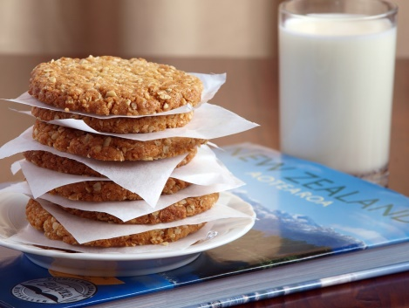

**ANZAC Cookies**

In a bowl, combine: 1 cup flour 1 cup rolled oats 2/3 cup brown sugar 2/3 cup desiccated coconut

Options - add: 2/3 cup raisins, and/or ½ cup chopped walnuts

In a pot, melt: ½ cup butter 2 tablespoons corn syrup or maple syrup

Add to the melted butter and syrup: ¼ teaspoon baking soda in 2 tablespoons of very hot water. It will foam up.

Add the melted butter to the dry ingredients, and stir to combine.

Form teaspoons of the mixture into balls and place on a greased or non-stick cookie sheet. You should get 20 to 25 cookies.

Bake in a 350 degree oven for 13 minutes for chewy cookies, or 20 minutes for crisp cookies. Let the cookies cool on the cookie sheet before starting to eat them! *Les Dickie a.k.a Tim’s Dad*

**The Moonlighters and Sunshiners Short Stories** *At recent meetings of the Moonlighters and Sunshiners groups, the members composed – and illustrated – short stories, as follows:*

**Sunshiners** It was a dark and stormy night. Frederick was curled up under the covers, hoping to have a nice peaceful dream. Then the electricity was cut off. He dreamt of spooky things like a ghost in his room. Then he woke up and a bat was flying in his room. Frederick opened his window, and the bat flew into the lightning and thundering sky. With a loud crash, a huge branch broke off the tree, and birds and goblins flew into the sky. Then Frederick remembered it was Halloween, and put on his Batman costume and went on his way trick-or-treating.

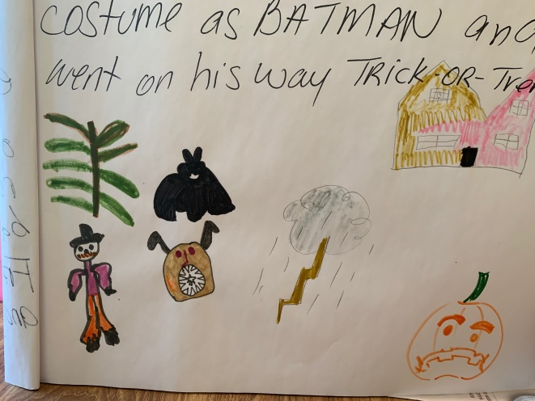

**Moonlighters** This summer my family got together and we had a family reunion. My cousins, the fairies and the elves, joined us from Ireland. We went swimming in the river. We saw lots of fish and eels. I was so excited and happy to see those creatures. We all ate hamburgers and juicy cheese dogs. We were all dancing to live music. Uncle Jerry caught a rainbow because it rained before. He found a pot of gold. Uncle Jerry decided to take the whole family, the elves, the fairies, fish and eels, on a cruise.

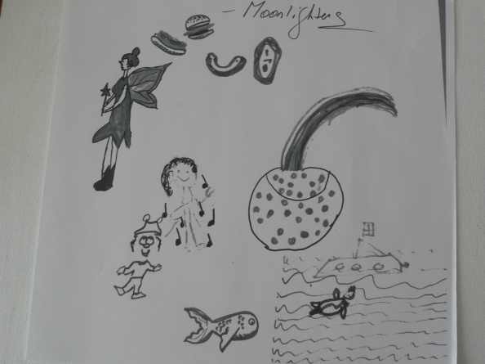

**The Jazz Festival** This summer I went to the Jazz Festival in Montreal. There were bands from a number of countries – one was from India, and I enjoyed that one. There was another one with a guitar that I really liked. There was a huge crowd of people, tourists as well as Montrealers. It was pretty hot when I was there, but I had fun and enjoyed the evening.

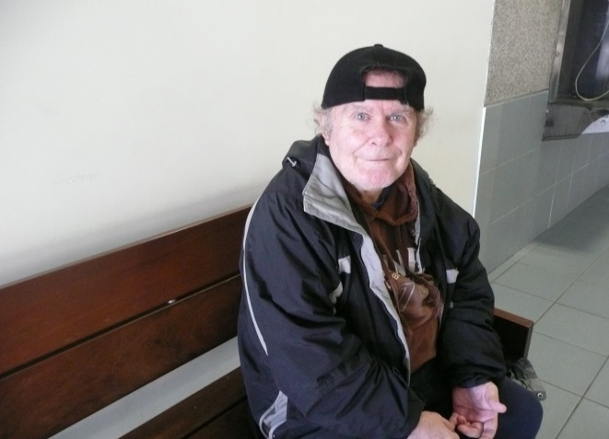

I usually go to the Jazz Festival and to Les Francofolies, and I went to both this year. *John Neale*

**Birthdays celebrated at the November Potluck**

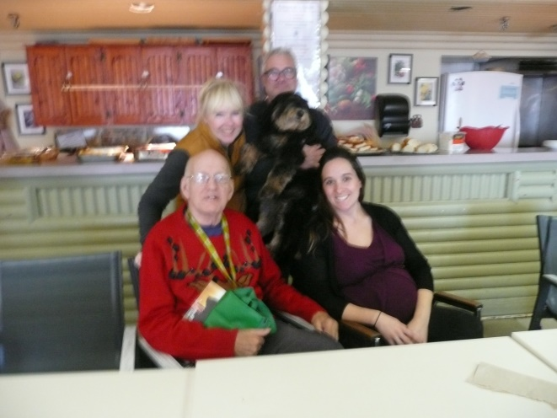

*Charles and his family: Susan, Ken, Caroline and Malka (the furry one!)*

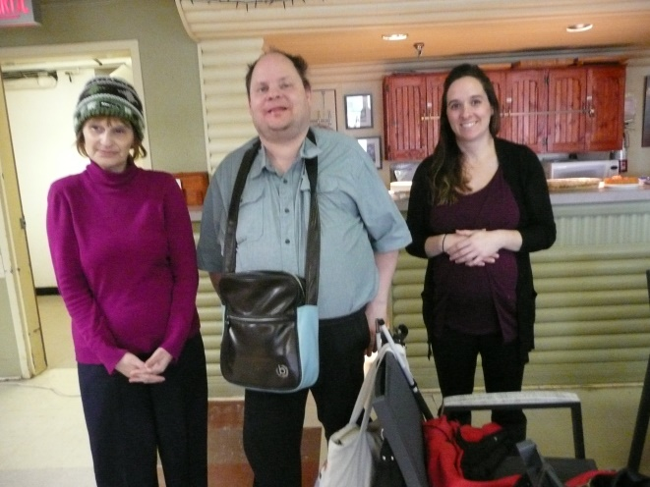

*Angelina, Petros, and special guest Caroline*.

**The Fay Bland Award, 2019** Every year, the Fay Bland Award is given to a person or group who has made a significant contribution to AVATIL.

This year’s award winner was Kevin Ley, a long-time and lively member of AVATIL. He graduated from the transitional program, and lives independently. He presently does maintenance work inside and outside our building as a member of a team. Kevin is a caring person, often arriving ahead of time, greeting people cheerfully as they arrive at the door. For years, Kevin has been involved in our groups, among them, the choir, where he is both a member and an accomplished soloist.

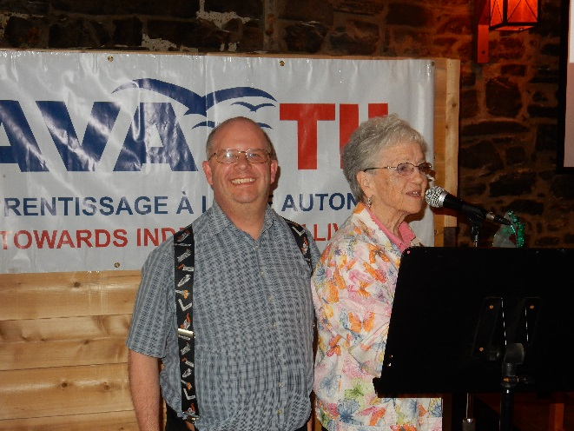

We all wish him well, and thank him for his service to AVATIL. *Carita Dubuc*

**A Summer BBQ Memory**

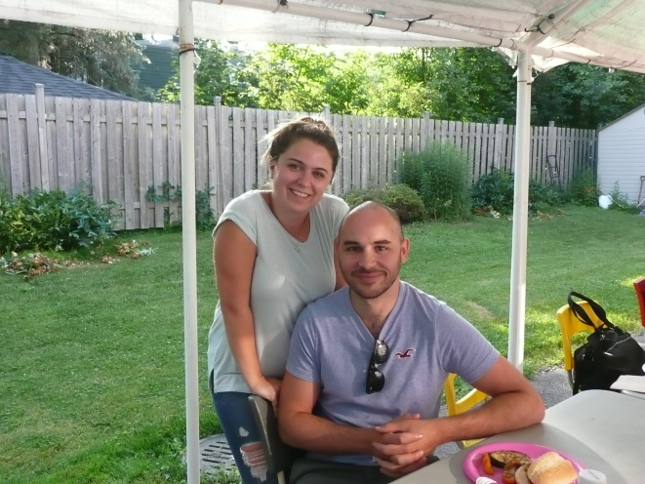

*A special visitor, Amanda’s husband!*

**Sharon’s Art Group at Lunch and Games**

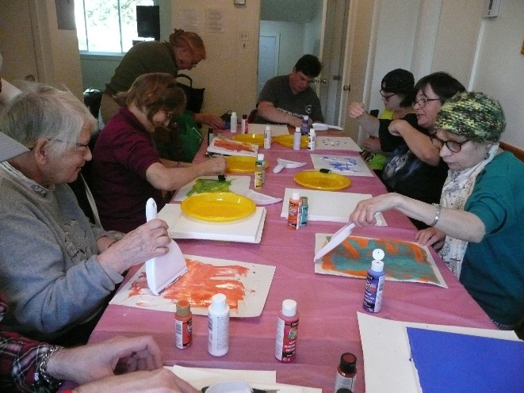

*Dear readers,*

*I’ve been the editor of the Newsletter since December, 2003. Now, it’s time for me to retire and let someone new take charge. But I’ve promised to continue to help with some interviews - always the most enjoyable part of the job!*

*And I would like to thank all the past contributors – the writers and those who gave us photos and technical assistance.*

*And I would like to add a special thanks to Mojgan for her great help with this issue.*

*You have helped to record a history of our wonderful Comitas group. And finally, I ask all of you to keep on contributing articles to our newsletter and to keep on reading!*

*Maureen Anderson*

**

**Happy Holidays to all our readers!**

**Remembering John Houtman**

In March of this year, John Houtman, Lena’s Dad, passed away suddenly after a brief illness.

I first met Mr. Houtman about sixteen years ago at an information meeting on different organizations and services. My son Terry was there as well, and happened to tell Mr. Houtman about living at AVATIL. Because Mr. Houtman had never heard about us, Terry asked me to speak to him. It turned out that Mr. Houtman’s adult daughter, Lena, who was living with him, had already learned many skills for independent living. He had been looking for an organization that would help Lena learn how to live on her own. After her Dad looked into it further, Lena joined AVATIL, graduated after two years in the residential program, and has lived in her own apartment for many years now.

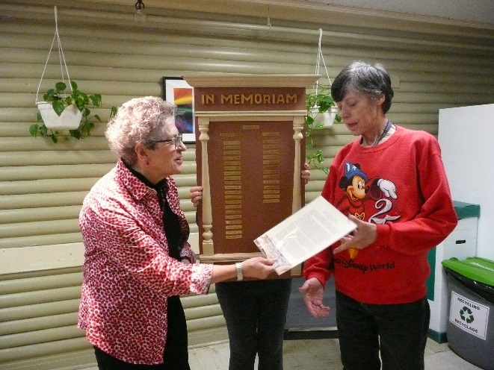

Mr. Houtman had told me many times how happy he was to have found AVATIL, and how much the program had helped make Lena become more independent.

*Marjie Rutherford*

